Smart farm:

For farmers and growers, the Internet of Things has opened up extremely productive ways to cultivate soil and raise livestock with the use of cheap, easy-to-install sensors and an abundance of insightful data they offer. Prospering on this prolific build-up of the IOT in agriculture, smart farming applications are gaining ground with the promise to deliver 24/7 visibility into soil and crop health.

We believe that our concept will be a benchmark in the agrobusiness due to its reliability and remote monitoring. Our idea tries to digitalize farming and agricultural activities so that the farmers can check on the requirements of the crops and accurately predict their growth

Features: The aim of this project is to introduce the latest technology into the agriculture business and better crop production by collecting real-time status of crop and informing the farmers about it.

1. Soil fertility and temperature monitoring.
2. SMS / wireless connectivity with real-time data being shown
3. Crop rotation suggestion based on map and soil data
4. Tractor efficiency path describer.
5. Automatic irrigation scheduler.

All the data from the sensor will be fetched and hosted on the web-app which is created using bootstrap and PHP.

Components list:

1. **Wireless module for arduino(ESP 8266 or anything that he has)**
2. **Soil Moisture Sensor ( with LM393 Driver)**
3. **LM35 Temperature Sensor/DHT22 Digital Temperature and Humidity Sensor**
4. **16x2 LCD Display**
5. **5V Relay**
6. **Resistors** (1kohm+some others)
7. **5mm LED**
8. **Motor(5v dc motor just to simulate the water pump if necessary)**

Sources:

* Code for soil data monitoring along with SMS available here:

<https://github.com/akshat0395/IoT_based_Smart_Farming/blob/master/Code.c>

* Irrigation scheduler:

Pretty simple, run a system timer and schedule the running of a pump when designated time

<http://www.instructables.com/id/Automatic-Irrigation-System-for-Indoor-Gardening-U/>

* Tractor efficiency path describer:

Using Minimum Spanning Tree algo or other graph traversal algorithm. Code easily findable.

PS: cant use MST or any other graph traversal algorithm, instead we will use a computer graphics algorithm, where the pixel size equal to tractor dimensions.

<https://www.geeksforgeeks.org/scan-line-polygon-filling-using-opengl-c/>

* Crop rotation suggestion using weather forecasting and data from the arduino, doable.

ALL OF WHICH WILL BE HOSTED ON A WEB APPLICATION USING PHP BOOTSTRAP AND JS

We will soon start this: components ka shortlist we will do tonight.

Components list:

1. **Wireless module for arduino(ESP 8266 or anything that he has)**
2. **Soil Moisture Sensor ( with LM393 Driver)**
3. **LM35 Temperature Sensor/DHT22 Digital Temperature and Humidity Sensor**
4. **16x2 LCD Display**
5. **5V Relay**
6. **Resistors** (1kohm+some others)
7. **5mm LED**
8. **Motor(5v dc motor just to simulate the water pump if necessary)**

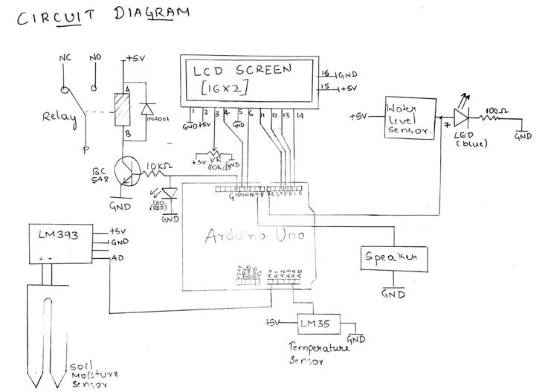

(Resistors ke liye)

Web interface will need to have:

* Db to store farmer details
* Water tank level monitor
* Tractor schedule(Along with other graphics to portray the algorithm for most efficient path.)
* Weather forecast/rain expectation/warnings/humidity temperature readings
* Crop rotation suggestion along with soil and air conditions

Modules:

* Login
* Dashboard- will contain easy to understand important details of everything(Weather, Temp, Water level, Soil condition,etc.)
* Water level and scheduler interface
* Tractor and algorithm graphics interface
* Soil conditions and crop rotation suggestor interface

<https://github.com/Tanibox/tania>

Please refer to this project, it is somewhat the finished version of what i want our web application to look like, unfortunately we can try replicating this git or start from scratch so its up to you guys.

<https://drive.google.com/file/d/1L21mweXcklOz2-7mGN55PbSc8LYp8wtR/view?usp=sharing>

Link for the firebase app with the dashboard

<http://zeflo.com/2014/esp8266-weather-display/>

Using the esp to display weather data, with code

<http://www.instructables.com/id/ESP8266-Temp-Humidity-Monitoring-Web-App-Using-Ard/>

Humidity temp with web app :)

(Link to code)

<https://github.com/bhaskar-anil429/ESP8266-Weather-web-app>

ESP 8266- send data to webserver

<https://circuitdigest.com/microcontroller-projects/sending-arduino-data-to-webpage>

<?php  
$file = "./content/welcome.txt";  
$f = fopen($file, "r") or exit("Unable to open file!");  
*// read file line by line until the end of file (feof)*  
while(!feof($f))  
{  
 echo fgets($f)."<br />";  
}  
  
fclose($f);  
?>

[Kludge final code](https://drive.google.com/file/d/1gZHRGb2u4o-4LOz_T6dPmSRLzqbdBR-L/view?usp=sharing)